National Fire Cadets

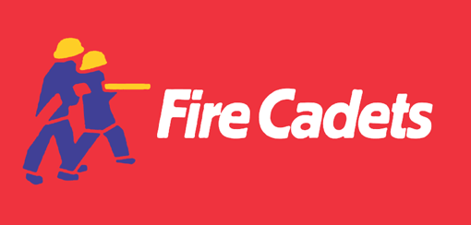 

**NATIONAL FIRE CADETS VISION:** A world class, inclusive and progressive youth organisation, supported by Fire and Rescue Services (FRSs), which inspires and empowers young people through nationally recognised community-centred programmes

**MISSION:** Open to all, we empower individuals to reach their full potential through a fun and progressive programme that delivers social action and skills development, contributing to safer, stronger and healthier communities

**Underlying Principles**

* National brand, uniform, logo
* National charter
* Core target age 13 up to 18
* Shared vision, mission & aims
* Contribution to safer, stronger communities through social action
* Provides internal progression and recognition opportunities
* Route towards achievement of recognised qualifications on a modular basis
* Volunteer opportunities open to all
* Minimum programme length 12 months

|  |  |  |
| --- | --- | --- |
| **AIMS** | | |
| Aim 1. Fire Cadets are supported, empowered & provided with personal development opportunities suited to their abilities and aspirations | Aim 2. Fire Cadets contribute to local FRS Social Actions that lead to safer, stronger and healthier communities | Aim 3. An accountable nationally recognised framework that delivers an effective, efficient and transferable programme ensuring continued growth and sustainability |
| **OBJECTIVES** | | |
| a) Agreed National Fire Cadet Framework is widely adopted by FRSs which is inclusive and accessible to 13-18 year olds | a) Fire Cadets develop and deliver social actions that benefit communities and fire cadets | a) National Fire Cadets (NFC) is a nationally recognised Uniformed Youth programme |
| b) Nationally accredited qualifications and progression routes are adopted by Fire Cadets | b) Develop Fire Cadets' knowledge and awareness of their communities to enhance their citizenship skills | b) Open and transparent framework that is implemented across UK FRSs |
| c) Fire Cadets achieve enhanced life skills | c) Provide quality volunteering opportunities for adults that provide personal and professional development | c) Young people voices contribute to the ongoing development and review of National Fire Cadets |
| d) Improve Fire Cadets’ employability skills |  | d) Share notable practice while continuing to learn, strengthening networks and partnerships to support the programme |
| e) Fire Cadets experience challenging, enjoyable and fun activities that enhance their health, wellbeing and life opportunities |  | e) Develop a robust governance and communication structure to ensure we deliver our aims |

**VALUES**

* Equality and diversity

Fairness and respect

* Recognition of merit

Honesty, integrity and mutual trust

* Personal development

Service to the community

* A ‘can do’ attitude

Inclusion

**By 2020 the National Fire Cadets will:**

* Be widely recognised nationally and internationally as a uniformed youth organisation respected for excellence, opportunity and inclusion, inspiring young people to achieve their potential
* Ensure that decision-making is consistently influenced by the views and opinions of its young members
* Have robust structures, processes based on collaborative leadership
* Be financially stable with diverse income streams and resources that support the development of young people
* Expand our international opportunities